4.15. CONFIGURACION DE MRTG
MRTG usa SNMP (Simple Networque Management Protocol) para recolectar los datos de tráfico de un determinado dispositivo (routers o servidores).

Software requerido para el funcionamiento de MRTG:
- net-snmp-5.1 o superior
- net-snmp-utils-5.1 o superior
- mrtg-2.14.5-2

Verificamos que el snmp este instalado y revisamos su versión:

Se verifica que el snmp esta instalado y activo:

[root@www mrtg]# rpm -a -q | grep snmp
net-snmp-libs-5.3.1-11.fc6

Faltan algunos módulos que se descargan de internet y se ubican en instaladores:

[root@www instaladores]# ls *snmp*
net-snmp-5.3.1-11.fc6.i386.rpm net-snmp-perl-5.3.1-11.fc6.i386.rpm
net-snmp-devel-5.3.1-11.fc6.i386.rpm net-snmp-utils-5.3.1-11.fc6.i386.rpm
[root@www instaladores]#
[root@www instaladores]# rpm -ivh net-snmp-5.3.1-11.fc6.i386.rpm
Preparing... ########################################### [100%]
1:net-snmp ########################################### [100%]
[root@www instaladores]# rpm -ivh net-snmp-devel-5.3.1-11.fc6.i386.rpm
error: Failed dependencies:
beecrypt-devel is needed by net-snmp-devel-5.3.1-11.fc6.i386
elfutils-devel is needed by net-snmp-devel-5.3.1-11.fc6.i386
[root@www instaladores]# rpm -ivh net-snmp-utils-5.3.1-11.fc6.i386.rpm
Preparing... ########################################### [100%]
1:net-snmp-utils ########################################### [100%]
[root@www instaladores]# rpm -ivh net-snmp-perl-5.3.1-11.fc6.i386.rpm
Preparing... ########################################### [100%]
1:net-snmp-perl ########################################### [100%]

[root@www /]# rpm -aq | grep snmp
net-snmp-libs-5.3.1-11.fc6
net-snmp-utils-5.3.1-11.fc6
net-snmp-5.3.1-11.fc6
net-snmp-perl-5.3.1-11.fc6
[root@www /]#

Se deben crear las entradas correspondientes en el fichero /etc/snmp/snmpd.conf que servirán para definir quien tendrá acceso hacia el servicio snmpd. Sin embargo no olvidar hacer una copia del archivo de configuración del snmpd.conf:

[root@www instaladores]# cd /etc/snmp
[root@www snmp]#cp snmpd.conf snmpd.conf.ori
[root@www snmp]#ls
snmpd.conf snmpd.conf.ori

[root@www snmp]# cat snmpd.conf

# Listas de control de acceso (ACL)
## sec.name source community (alias clave de acceso)
com2sec local 192.168.1.1 public

#Se asigna ACL al grupo de lectura escritura, en este caso no lo asignamos a ningun grupo.
group notConfigGroup v1 local
group notConfigGroup v2c local

# Ramas MIB que se permiten ver
## name incl/excl subtree mask(optional)
view all included .1 80

# Establece permisos de lectura y escritura en este caso solo de lectura.
## group context sec.model sec.level prefix read write notif
access notConfigGroup "" any noauth exact all none none

# Información de Contacto del Sistema
syslocation Servidor Linux en imf.com.co
syscontact Administrador

Iniciar el servicio y añadirlo a los servicios de arranque del sistema:
Inicie el servicio de SNMP y añada éste al resto de los servicios que arrancan junto con el sistema:

[root@www snmp]# service snmpd restart
Parando snmpd: [ OK ]
Iniciando snmpd: [ OK ]
[root@www ~]# chkconfig snmpd on

Se configura para que el servicio siempre inicie con la máquina:

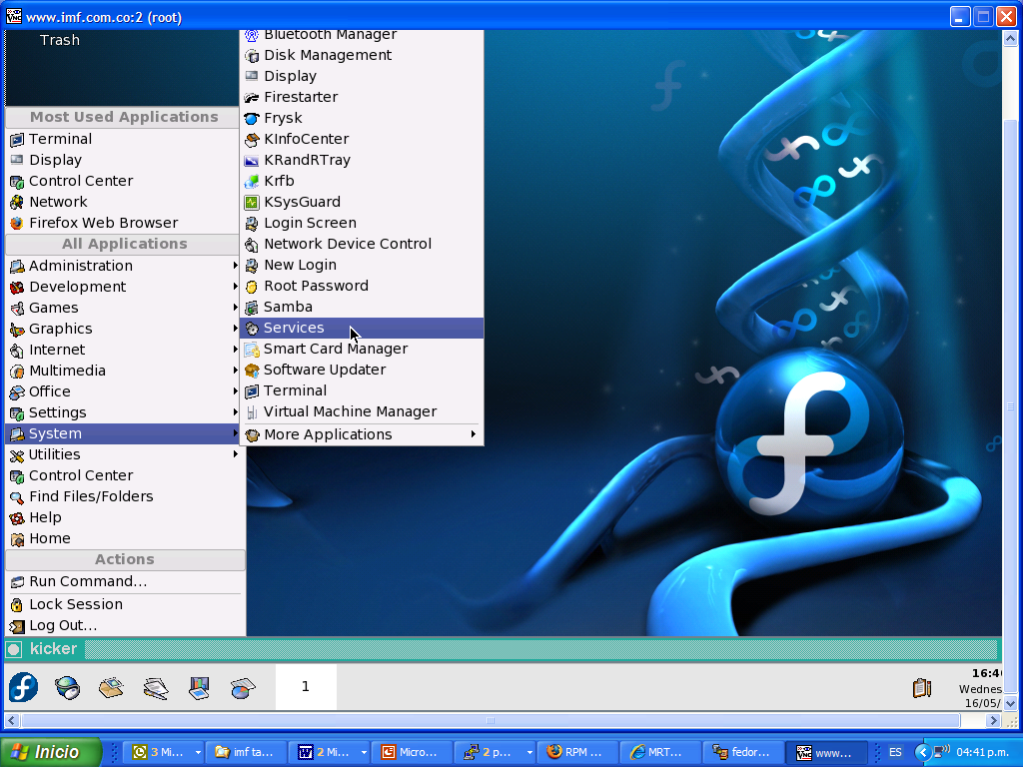

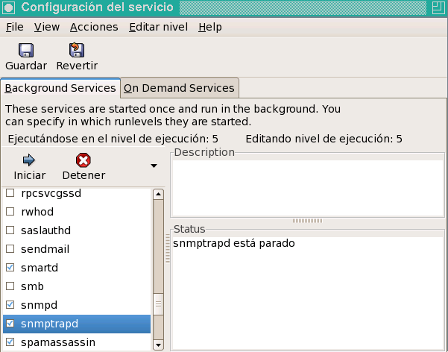

Comprobamos el correcto funcionamiento del snmp: Como se asigno clave de acceso public en el sistema con dirección IP es 192.168.1.1, para probar si la configuración funciona, solo hay que ejecutar los dos siguiente mandatos a fin verificar que devuelvan información acerca del sistema consultado.

[root@www ~]# snmpwalk -v 1 -c public 192.168.1.1 system
SNMPv2-MIB::sysDescr.0 = STRING: Linux www.imf.com.co 2.6.18-1.2798.fc6 #1 SMP Mon Oct 16 14:37:32 EDT 2006 i686
SNMPv2-MIB::sysObjectID.0 = OID: NET-SNMP-MIB::netSnmpAgentOIDs.10
DISMAN-EVENT-MIB::sysUpTimeInstance = Timeticks: (4361) 0:00:43.61
SNMPv2-MIB::sysContact.0 = STRING: Root <root@localhost> (configure /etc/snmp/snmp.local.conf)
SNMPv2-MIB::sysName.0 = STRING: www.imf.com.co
SNMPv2-MIB::sysLocation.0 = STRING: Unknown (edit /etc/snmp/snmpd.conf)
SNMPv2-MIB::sysORLastChange.0 = Timeticks: (1) 0:00:00.01
SNMPv2-MIB::sysORID.1 = OID: SNMPv2-MIB::snmpMIB
SNMPv2-MIB::sysORID.2 = OID: TCP-MIB::tcpMIB
SNMPv2-MIB::sysORID.3 = OID: IP-MIB::ip
SNMPv2-MIB::sysORID.4 = OID: UDP-MIB::udpMIB
SNMPv2-MIB::sysORID.5 = OID: SNMP-VIEW-BASED-ACM-MIB::vacmBasicGroup
SNMPv2-MIB::sysORID.6 = OID: SNMP-FRAMEWORK-MIB::snmpFrameworkMIBCompliance
SNMPv2-MIB::sysORID.7 = OID: SNMP-MPD-MIB::snmpMPDCompliance
SNMPv2-MIB::sysORID.8 = OID: SNMP-USER-BASED-SM-MIB::usmMIBCompliance
SNMPv2-MIB::sysORDescr.1 = STRING: The MIB module for SNMPv2 entities
SNMPv2-MIB::sysORDescr.2 = STRING: The MIB module for managing TCP implementations
SNMPv2-MIB::sysORDescr.3 = STRING: The MIB module for managing IP and ICMP implementations
SNMPv2-MIB::sysORDescr.4 = STRING: The MIB module for managing UDP implementations
SNMPv2-MIB::sysORDescr.5 = STRING: View-based Access Control Model for SNMP.
SNMPv2-MIB::sysORDescr.6 = STRING: The SNMP Management Architecture MIB.
SNMPv2-MIB::sysORDescr.7 = STRING: The MIB for Message Processing and Dispatching.
SNMPv2-MIB::sysORDescr.8 = STRING: The management information definitions for the SNMP User-based Security Model.
SNMPv2-MIB::sysORUpTime.1 = Timeticks: (1) 0:00:00.01
SNMPv2-MIB::sysORUpTime.2 = Timeticks: (1) 0:00:00.01
SNMPv2-MIB::sysORUpTime.3 = Timeticks: (1) 0:00:00.01
SNMPv2-MIB::sysORUpTime.4 = Timeticks: (1) 0:00:00.01
SNMPv2-MIB::sysORUpTime.5 = Timeticks: (1) 0:00:00.01
SNMPv2-MIB::sysORUpTime.6 = Timeticks: (1) 0:00:00.01
SNMPv2-MIB::sysORUpTime.7 = Timeticks: (1) 0:00:00.01
SNMPv2-MIB::sysORUpTime.8 = Timeticks: (1) 0:00:00.01
[root@www ~]#

[root@www ~]# snmpwalk -v 1 -c public 192.168.1.1 interface
IF-MIB::ifNumber.0 = INTEGER: 4
IF-MIB::ifIndex.1 = INTEGER: 1
IF-MIB::ifIndex.2 = INTEGER: 2
IF-MIB::ifIndex.3 = INTEGER: 3
IF-MIB::ifIndex.4 = INTEGER: 4
IF-MIB::ifDescr.1 = STRING: lo
IF-MIB::ifDescr.2 = STRING: eth1
IF-MIB::ifDescr.3 = STRING: eth0
IF-MIB::ifDescr.4 = STRING: sit0
IF-MIB::ifType.1 = INTEGER: softwareLoopback(24)
IF-MIB::ifType.2 = INTEGER: ethernetCsmacd(6)
IF-MIB::ifType.3 = INTEGER: ethernetCsmacd(6)
IF-MIB::ifType.4 = INTEGER: tunnel(131)
IF-MIB::ifMtu.1 = INTEGER: 16436
IF-MIB::ifMtu.2 = INTEGER: 1500
IF-MIB::ifMtu.3 = INTEGER: 1500
IF-MIB::ifMtu.4 = INTEGER: 1480
IF-MIB::ifSpeed.1 = Gauge32: 10000000
IF-MIB::ifSpeed.2 = Gauge32: 0
IF-MIB::ifSpeed.3 = Gauge32: 100000000
IF-MIB::ifSpeed.4 = Gauge32: 0
IF-MIB::ifPhysAddress.1 = STRING:
IF-MIB::ifPhysAddress.2 = STRING: 0:18:fe:77:42:f9
IF-MIB::ifPhysAddress.3 = STRING: 0:c:46:cd:e0:3
IF-MIB::ifPhysAddress.4 = STRING:
IF-MIB::ifAdminStatus.1 = INTEGER: up(1)
IF-MIB::ifAdminStatus.2 = INTEGER: up(1)
IF-MIB::ifAdminStatus.3 = INTEGER: up(1)
IF-MIB::ifAdminStatus.4 = INTEGER: down(2)
IF-MIB::ifOperStatus.1 = INTEGER: up(1)
IF-MIB::ifOperStatus.2 = INTEGER: down(2)
IF-MIB::ifOperStatus.3 = INTEGER: up(1)
IF-MIB::ifOperStatus.4 = INTEGER: down(2)
IF-MIB::ifLastChange.1 = Timeticks: (0) 0:00:00.00
IF-MIB::ifLastChange.2 = Timeticks: (0) 0:00:00.00
IF-MIB::ifLastChange.3 = Timeticks: (0) 0:00:00.00
IF-MIB::ifLastChange.4 = Timeticks: (0) 0:00:00.00
IF-MIB::ifInOctets.1 = Counter32: 23983
IF-MIB::ifInOctets.2 = Counter32: 0
IF-MIB::ifInOctets.3 = Counter32: 34634
IF-MIB::ifInOctets.4 = Counter32: 0
IF-MIB::ifInUcastPkts.1 = Counter32: 276
IF-MIB::ifInUcastPkts.2 = Counter32: 0
IF-MIB::ifInUcastPkts.3 = Counter32: 124
IF-MIB::ifInUcastPkts.4 = Counter32: 0
IF-MIB::ifInNUcastPkts.1 = Counter32: 0
IF-MIB::ifInNUcastPkts.2 = Counter32: 0
IF-MIB::ifInNUcastPkts.3 = Counter32: 0
IF-MIB::ifInNUcastPkts.4 = Counter32: 0
IF-MIB::ifInDiscards.1 = Counter32: 0
IF-MIB::ifInDiscards.2 = Counter32: 0
IF-MIB::ifInDiscards.3 = Counter32: 0
IF-MIB::ifInDiscards.4 = Counter32: 0
IF-MIB::ifInErrors.1 = Counter32: 0
IF-MIB::ifInErrors.2 = Counter32: 0
IF-MIB::ifInErrors.3 = Counter32: 0
IF-MIB::ifInErrors.4 = Counter32: 0
IF-MIB::ifInUnknownProtos.1 = Counter32: 0
IF-MIB::ifInUnknownProtos.2 = Counter32: 0
IF-MIB::ifInUnknownProtos.3 = Counter32: 0
IF-MIB::ifInUnknownProtos.4 = Counter32: 0
IF-MIB::ifOutOctets.1 = Counter32: 23983
IF-MIB::ifOutOctets.2 = Counter32: 0
IF-MIB::ifOutOctets.3 = Counter32: 21116
IF-MIB::ifOutOctets.4 = Counter32: 0
IF-MIB::ifOutUcastPkts.1 = Counter32: 276
IF-MIB::ifOutUcastPkts.2 = Counter32: 0
IF-MIB::ifOutUcastPkts.3 = Counter32: 139
IF-MIB::ifOutUcastPkts.4 = Counter32: 0
IF-MIB::ifOutNUcastPkts.1 = Counter32: 0
IF-MIB::ifOutNUcastPkts.2 = Counter32: 0
IF-MIB::ifOutNUcastPkts.3 = Counter32: 0
IF-MIB::ifOutNUcastPkts.4 = Counter32: 0
IF-MIB::ifOutDiscards.1 = Counter32: 0
IF-MIB::ifOutDiscards.2 = Counter32: 0
IF-MIB::ifOutDiscards.3 = Counter32: 0
IF-MIB::ifOutDiscards.4 = Counter32: 0
IF-MIB::ifOutErrors.1 = Counter32: 0
IF-MIB::ifOutErrors.2 = Counter32: 0
IF-MIB::ifOutErrors.3 = Counter32: 0
IF-MIB::ifOutErrors.4 = Counter32: 0
IF-MIB::ifOutQLen.1 = Gauge32: 0
IF-MIB::ifOutQLen.2 = Gauge32: 0
IF-MIB::ifOutQLen.3 = Gauge32: 0
IF-MIB::ifOutQLen.4 = Gauge32: 0
IF-MIB::ifSpecific.1 = OID: SNMPv2-SMI::zeroDotZero
IF-MIB::ifSpecific.2 = OID: SNMPv2-SMI::zeroDotZero
IF-MIB::ifSpecific.3 = OID: SNMPv2-SMI::zeroDotZero
IF-MIB::ifSpecific.4 = OID: SNMPv2-SMI::zeroDotZero
[root@www ~]#

Ahora se descarga de Internet las fuentes de MRTG, y lo ubicamos en /opt/instaladores que es en donde estan todos los paquetes instalados en nuestro sistema:

[root@www instaladores]# rpm -ivh mrtg-2.14.5-2.i386.rpm
Preparing... ########################################### [100%]
1:mrtg ########################################### [100%]
[root@www instaladores]#

Vamos al archivo de configuracion de mrtg:

[root@practica ~]# cd /etc/mrtg
[root@practica mrtg]# cp mrtg.conf mrtg.conf.ori
mrtg.cfg mrtg.conf.ori

Creamos un nuevo archivo mrtg con unas especificaciones propias para que direccione las estadisticas graficas a /home/web/mrtg y salida del archivo en /etc/mrtg/mrtg.cfg del router con ip 192,168,248,213

[root@practica mrtg]# cfgmaker --global "WorkDir: /home/web/mrtg" --global "Options[_]: bits,growright" --output /etc/mrtg/mrtg.cfg public@192.168.1.1

Vamos al archivo de configuracion de mrtg para observer cuantas Interfaces posee el dispositivo:

[root@www ]#cd /etc/mrtg
[root@www mrtg]# cat mrtg.cfg
# Created by
# /usr/bin/cfgmaker --global 'WorkDir: /home/web/mrtg' --global 'Options[_]: bits,growright' --output /etc/mrtg/mrtg.cfg public@192.168.1.1

### Global Config Options

# for UNIX
# WorkDir: /home/http/mrtg

# or for NT
# WorkDir: c:\mrtgdata

### Global Defaults

# to get bits instead of bytes and graphs growing to the right
# Options[_]: growright, bits

EnableIPv6: no
WorkDir: /home/web/mrtg
Options[_]: bits,growright

######################################################################
# System: www.imf.com.co
# Description: Linux www.imf.com.co 2.6.18-1.2798.fc6 #1 SMP Mon Oct 16 14:37:32 EDT 2006 i686
# Contact: Root <root@localhost> (configure /etc/snmp/snmp.local.conf)
# Location: Unknown (edit /etc/snmp/snmpd.conf)
######################################################################

### Interface 1 >> Descr: 'lo' | Name: 'lo' | Ip: '127.0.0.1' | Eth: '' ###
### The following interface is commented out because:
### * it is a Software Loopback interface
#
# Target[192.168.1.1_1]: 1:public@192.168.1.1:
# SetEnv[192.168.1.1_1]: MRTG_INT_IP="127.0.0.1" MRTG_INT_DESCR="lo"
# MaxBytes[192.168.1.1_1]: 1250000
# Title[192.168.1.1_1]: Traffic Analysis for 1 -- www.imf.com.co
# PageTop[192.168.1.1_1]: <h1>Traffic Analysis for 1 -- www.imf.com.co</h1>
# <div id="sysdetails">
# <table>
# <tr>
# <td>System:</td>
# <td>www.imf.com.co in Unknown (edit /etc/snmp/snmpd.conf)</td>
# </tr>
# <tr>
# <td>Maintainer:</td>
# <td>Root &lt;root@localhost&gt; (configure /etc/snmp/snmp.local.conf)</td>
# </tr>
# <tr>
# <td>Description:</td>
# <td>lo </td>
# </tr>
# <tr>
# <td>ifType:</td>
# <td>softwareLoopback (24)</td>
# </tr>
# <tr>
# <td>ifName:</td>
# <td>lo</td>
# </tr>
# <tr>
# <td>Max Speed:</td>
# <td>10.0 Mbits/s</td>
# </tr>
# <tr>
# <td>Ip:</td>
# <td>127.0.0.1 (localhost.localdomain)</td>
# </tr>
# </table>
# </div>

### Interface 2 >> Descr: 'eth0' | Name: 'eth0' | Ip: '10.21.28.2' | Eth: '00-0c-46-cd-e0-03' ###

Target[192.168.1.1_2]: 2:public@192.168.1.1:
SetEnv[192.168.1.1_2]: MRTG_INT_IP="10.21.28.2" MRTG_INT_DESCR="eth0-externa"
MaxBytes[192.168.1.1_2]: 1250000
Title[192.168.1.1_2]: Analisis Trafica canal WAN -- www.imf.com.co
PageTop[192.168.1.1_2]: <h1>Analisis canal wan -- www.imf.com.co</h1>
<div id="sysdetails">
<table>
<tr>
<td>System:</td>
<td>www.imf.com.co in Unknown (edit /etc/snmp/snmpd.conf)</td>
</tr>
<tr>
<td>Maintainer:</td>
<td>Root &lt;root@localhost&gt; (configure /etc/snmp/snmp.local.conf)</td>
</tr>
<tr>
<td>Description:</td>
<td>eth0 </td>
</tr>
<tr>
<td>ifType:</td>
<td>ethernetCsmacd (6)</td>
</tr>
<tr>
<td>ifName:</td>
<td>eth0</td>
</tr>
<tr>
<td>Max Speed:</td>
<td>10.0 Mbits/s</td>
</tr>
<tr>
<td>Ip:</td>
<td>10.21.28.2 ()</td>
</tr>
</table>
</div>

### Interface 3 >> Descr: 'eth1' | Name: 'eth1' | Ip: '192.168.1.1' | Eth: '00-18-fe-77-42-f9' ###

#Target[192.168.1.1_3]: 3:public@192.168.1.1:
#SetEnv[192.168.1.1_3]: MRTG_INT_IP="192.168.1.1" MRTG_INT_DESCR="eth1"
#MaxBytes[192.168.1.1_3]: 12500000
#Title[192.168.1.1_3]: Traffic Analysis for 3 -- www.imf.com.co
#PageTop[192.168.1.1_3]: <h1>Traffic Analysis for 3 -- www.imf.com.co</h1>
<div id="sysdetails">
<table>
<tr>
<td>System:</td>
<td>www.imf.com.co in Unknown (edit /etc/snmp/snmpd.conf)</td>
</tr>
<tr>
<td>Maintainer:</td>
<td>Root &lt;root@localhost&gt; (configure /etc/snmp/snmp.local.conf)</td>
</tr>
<tr>
<td>Description:</td>
<td>eth1 </td>
</tr>
<tr>
<td>ifType:</td>
<td>ethernetCsmacd (6)</td>
</tr>
<tr>
<td>ifName:</td>
<td>eth1</td>
</tr>
<tr>
<td>Max Speed:</td>
<td>100.0 Mbits/s</td>
</tr>
<tr>
<td>Ip:</td>
<td>192.168.1.1 (www.imf.com.co)</td>
</tr>
</table>
</div>

### Interface 4 >> Descr: 'sit0' | Name: 'sit0' | Ip: '' | Eth: '' ###
### The following interface is commented out because:
### * it is administratively DOWN
### * it is operationally DOWN
### * has a speed of 0 which makes no sense
#
# Target[192.168.1.1_4]: 4:public@192.168.1.1:
# SetEnv[192.168.1.1_4]: MRTG_INT_IP="" MRTG_INT_DESCR="sit0"
# MaxBytes[192.168.1.1_4]: 0
# Title[192.168.1.1_4]: Traffic Analysis for 4 -- www.imf.com.co
# PageTop[192.168.1.1_4]: <h1>Traffic Analysis for 4 -- www.imf.com.co</h1>
# <div id="sysdetails">
# <table>
# <tr>
# <td>System:</td>
# <td>www.imf.com.co in Unknown (edit /etc/snmp/snmpd.conf)</td>
# </tr>
# <tr>
# <td>Maintainer:</td>
# <td>Root &lt;root@localhost&gt; (configure /etc/snmp/snmp.local.conf)</td>
# </tr>
# <tr>
# <td>Description:</td>
# <td>sit0 </td>
# </tr>
# <tr>
# <td>ifType:</td>
# <td>Encapsulation Interface (131)</td>
# </tr>
# <tr>
# <td>ifName:</td>
# <td>sit0</td>
# </tr>
# <tr>
# <td>Max Speed:</td>
# <td>0.0 bits/s</td>
# </tr>
# </table>
# </div>

El paquete de MRTG incluye un guión para crond, el cual se instala en la ruta /etc/cron.d/mrtg, de modo que éste ejecute MRTG, de forma automática, cada 5 minutos. Si se quiere comprobar la configuración solo es necesario esperar algunos minutos y consultar los resultados.

[root@www /]# cd /etc/cron.d/
[root@www cron.d]# ls
mailman mrtg
[root@www cron.d]# cat mrtg
*/5 * * * * root LANG=C LC_ALL=C /usr/bin/mrtg /etc/mrtg/mrtg.cfg --lock-file /var/lock/mrtg/mrtg_l --confcache-file /var/lib/mrtg/mrtg.ok
[root@www cron.d]#

Para poder visualizar en una sola pagina todas las interfaces asociadas al dispositivo a monitorear, ingresamos:

[root@www /]#indexmaker --output /home/web/mrtg/index.html /etc/mrtg/mrtg.cfg

Ahora es necesario revisar estos reportes a traves del navegador, para ello es necesario ir al directorio conf.d del apache y en el archivo mrtg moverlo para que en el httpd.conf se pueda especificar al Alias donde esta ubicada la pagina index.html generada por el mrtg y no cree conflicto:

[root@practica mrtg]# cd /etc/httpd/conf.d
[root@practica conf.d]# ls
auth_kerb.conf htdig.conf perl.conf squirrelmail.conf welcome.conf
auth_mysql.conf mailman.conf php.conf ssl.conf wordtrans.conf
auth_pgsql.conf manual.conf python.conf subversion.conf authz_ldap.conf mrtg.conf README webalizer.conf
[root@www conf.d]# cat mrtg.conf
#
# This configuration file maps the mrtg output (generated daily)
# into the URL space. By default these results are only accessible
# from the local host.
#
Alias /mrtg/ “ /home/web/mrtg”

<Location /mrtg>
Allow from
Allow from ::1
Allow from
</Location>
[root@www conf.d]# mv mrtg.conf mrtg.conf.ori

[root@practica conf.d]# cd ..
[root@www conf]# vi httpd.conf
Alias /mrtg/ "/home/web/mrtg/"

reiniciamos el apache para que tome los cambios;

[root@www /]# service httpd restart
Parando httpd: [ OK ]
Iniciando httpd: [ OK ]

Revisamos los permisos que contiene el directorio mrtg para que sea visualizado a traves del navegador

[root@www conf]# cd /home/web
[root@www web]# ls -l
total 24
-rw-r--r-- 1 root root 742 may 8 22:38 exten.html
-rw-r--r-- 1 root root 68 may 3 17:58 index.html
drwxr-xr-x 2 root root 4096 may 18 16:30 mrtg
-rw-r--r-- 1 root root 85 may 8 16:07 prohibit.html
drwxr-xr-x 6 apache apache 4096 may 17 12:44 reportes
-rw-r--r-- 1 root root 734 may 8 22:36 urls.html
[root@www web]# cd mrtg
[root@www mrtg]# ls -l
total 256
-rwxr-xr-x 1 apache root 1787 may 18 16:05 10.21.28.1_2-day.png
-rwxr-xr-x 1 apache root 6709 may 18 16:05 10.21.28.1_2.html
-rw-r--r-- 1 root root 48440 may 18 16:05 10.21.28.1_2.log
-rwxr-xr-x 1 apache root 1460 may 18 15:35 10.21.28.1_2-month.png
-rw-r--r-- 1 root root 48421 may 18 16:00 10.21.28.1_2.old
-rwxr-xr-x 1 apache root 1572 may 18 15:50 10.21.28.1_2-week.png
-rwxr-xr-x 1 apache root 1752 may 18 13:35 10.21.28.1_2-year.png
-rw-r--r-- 1 root root 1397 may 18 16:30 10.21.28.1_3-day.png
-rw-r--r-- 1 root root 6491 may 18 16:30 10.21.28.1_3.html
-rw-r--r-- 1 root root 48180 may 18 16:30 10.21.28.1_3.log
-rw-r--r-- 1 root root 1368 may 18 16:10 10.21.28.1_3-month.png
-rw-r--r-- 1 root root 48199 may 18 16:25 10.21.28.1_3.old
-rw-r--r-- 1 root root 1416 may 18 16:10 10.21.28.1_3-week.png
-rw-r--r-- 1 root root 1752 may 18 16:10 10.21.28.1_3-year.png
-rwxr-xr-x 1 apache root 2465 may 18 14:17 index.html
-rwxr-xr-x 1 apache root 538 may 18 13:35 mrtg-l.png
-rwxr-xr-x 1 apache root 414 may 18 13:35 mrtg-m.png
-rwxr-xr-x 1 apache root 1759 may 18 13:35 mrtg-r.png
[root@www mrtg]#

En el navegador se digita: http://192.168.1.1/mrtg , y lo que muestra es el analisis de trafico de la eth0 en bits por segundos vs. tiempo

