Name: _______________________________________________ Date: ______________________
CAUSATIVE SENTENCES
We sometimes cause somebody to do something for us. Causing somebody to do something for us is expressed by using a sentence pattern with ‘GET’ or ‘HAVE’. When you use this sentence pattern special care should be taken in breaking the parts of the sentence properly or else it might cause difficulty in understanding what is expressed.
- Analize the following pictures and utterances.
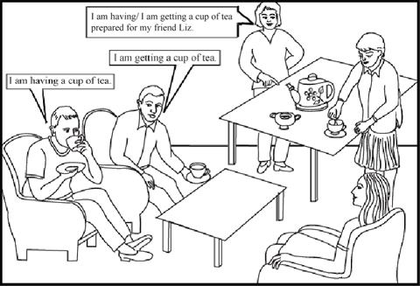
- I am having a cup of tea : ____________________________________________________
- I am getting a cup of tea: _____________________________________________________
- I am getting…a cup of tea prepared: ____________________________________________
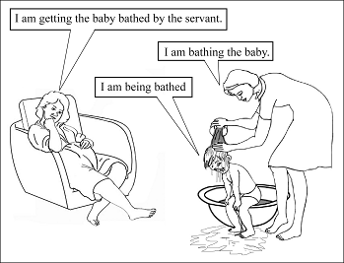
- I am bathing the baby: _______________________________________________________
- I am being bathed: __________________________________________________________
- I am getting … the baby bathed by the servant: _________________________________________________________________________
- Read the following examples. Notice how you should break the parts of the sentence:
- He is getting his car repaired by the mechanic.√
- He is getting his car repaired by the mechanic. ×
- I got my hair cut last Sunday.√
- I got my hair cut last Sunday. ×
- We get our clothes washed.√
- We get our clothes washed. ×

- The verb ‘GET’ is commonly used and ‘HAVE’ is formal. But the idea is the same.

He is having his car repaired.
I had my hair cut last Sunday.
We have our clothes washed
They are having their house painted.
I will have the broken chair mended tomorrow.

PASSIVE VOICE

- Convert these sentences from the active to the passive
- The grow coffee in Kenya.
_________________________________________________________________________
- A crocodile ate him in 1973.
_________________________________________________________________________
- They made fans in Spain.
_________________________________________________________________________
- The Romans built the bridge 1500 years ago.
_________________________________________________________________________
- Have they cleaned the swimming pool yet?
_________________________________________________________________________
- They sent her an invitation.
_________________________________________________________________________
- They asked him to leave.
_________________________________________________________________________
- They’ll serve you lunch on the plane.
_________________________________________________________________________
- They fined him $100.
_________________________________________________________________________
- They will tell you your results next week.
_________________________________________________________________________

- Complete the sentences with the passive forms of the verbs in brackets.
- Patients __________________________________________________ (treat) in hospitals.
- My passport is not ready yet. It _____________________________ (make) at the moment.
- The walls of the house ____________________________________________ (just/paint).
- The newspaper _____________________________________________ (bring) yesterday.
- While the potatoes ____________________________________ (peel) my parents arrived.
- Tomorrow all the compositions _________________________________________ (check).
- The car _____________________________________ (already/repair), now we can use it.
- The weather forecast ___________________________________ (broadcast) on TV at the moment, come and listen.
- While the ceiling __________________________ (paint) the bucket with the paint _______________________________ (upset).
- The order _____________________________________________________(not/make) yet.
- Your dress (make) at the moment and I think that tomorrow it __________________________________________________________________ (finish).
- My mother is busy at the moment. She cannot come. My baby brother ___________________________________________________________________ (feed).
- Coffee ________________________________________________________ (just/make) you can have a cup if you like.
- An interesting program ____________________________________ (show) on TV yesterday.
- Last lesson we ________________________________________________________ (tell) about different unusual animals.

